Equality Conditions

Definition
# Source: AI Source: Provided by: [Data Path: Persons Table -> ID Column: 1, Name_En Column: Motasem Essam] -> From: [ChatGPT] on [7/25/2026]
Equality Conditions are geometric conditions that require two or more geometric quantities, measurements, expressions, or properties to be exactly equal.
The fundamental symbol is:
$$\boxed{=}$$
An equality condition states that two quantities have the same mathematical value or measure.
$$\boxed{\text{Equality Condition}=\text{Requirement that two or more geometric quantities are equal}}$$
Examples
$$AB=CD$$
Two segments have equal lengths.
$$m∠A=m∠B$$
Two angles have equal measures.
$$\left[ABC\right]=\left[DEF\right]$$
Two figures have equal areas.
$$P_{1}=P_{2}$$
Two figures have equal perimeters.

Simple Definition
# Source: AI Source: Provided by: [Data Path: Persons Table -> ID Column: 1, Name_En Column: Motasem Essam] -> From: [ChatGPT] on [7/25/2026]
An Equality Condition is a geometric requirement stating that two or more geometric quantities or properties are exactly equal.
Examples:
- Equal lengths:
$$AB=CD$$
- Equal angles:
$$∠A=∠B$$
- Equal areas:
$$A_{1}=A_{2}$$
- Equal distances:
$$PA=PB$$
- Equal radii:
$$r_{1}=r_{2}$$

Main Types of Equality Conditions
# Source: AI Source: Provided by: [Data Path: Persons Table -> ID Column: 1, Name_En Column: Motasem Essam] -> From: [ChatGPT] on [7/25/2026]
A practical classification is:
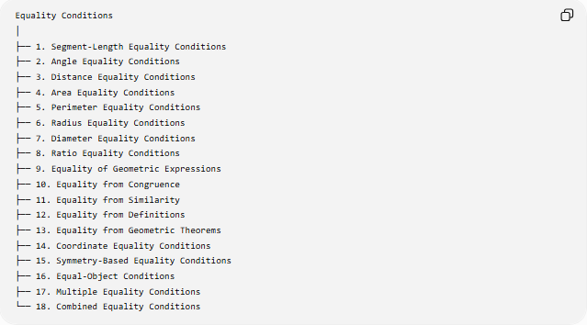
Equality Conditions
│
├── 1. Segment-Length Equality Conditions
├── 2. Angle Equality Conditions
├── 3. Distance Equality Conditions
├── 4. Area Equality Conditions
├── 5. Perimeter Equality Conditions
├── 6. Radius Equality Conditions
├── 7. Diameter Equality Conditions
├── 8. Ratio Equality Conditions
├── 9. Equality of Geometric Expressions
├── 10. Equality from Congruence
├── 11. Equality from Similarity
├── 12. Equality from Definitions
├── 13. Equality from Geometric Theorems
├── 14. Coordinate Equality Conditions
├── 15. Symmetry-Based Equality Conditions
├── 16. Equal-Object Conditions
├── 17. Multiple Equality Conditions
└── 18. Combined Equality Conditions
This is a practical/descriptive classification. The categories overlap because the same equality can arise from different geometric principles.

1. Segment-Length Equality Conditions
# Source: AI Source: Provided by: [Data Path: Persons Table -> ID Column: 1, Name_En Column: Motasem Essam] -> From: [ChatGPT] on [7/25/2026]
Definition
A Segment-Length Equality Condition states that two or more line segments have exactly the same length.
$$\boxed{AB=CD}$$
Example
If:
$$AB=8\text{ cm}$$
and:
$$CD=8\text{ cm},$$
then:
$$\boxed{AB=CD}.$$
Geometric Example
In an isosceles triangle:
$$\boxed{AB=AC}.$$
Therefore, the two sides have equal lengths.
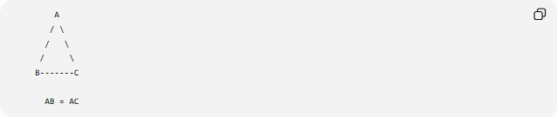
A
/ \
/ \
/ \
B-------C

AB = AC
Important Consequence
In a triangle:
$$AB=AC$$
implies:
$$\boxed{∠B=∠C}.$$
This is the Isosceles Triangle Theorem.

2. Angle Equality Conditions
# Source: AI Source: Provided by: [Data Path: Persons Table -> ID Column: 1, Name_En Column: Motasem Essam] -> From: [ChatGPT] on [7/25/2026]
Definition
An Angle Equality Condition states that two or more angles have equal measures.
$$\boxed{m∠A=m∠B}$$
Example
If:
$$m∠A={45}^{∘}$$
and:
$$m∠B={45}^{∘},$$
then:
$$\boxed{∠A=∠B}.$$
Vertical Angles
When two lines intersect:
$$\boxed{\text{Vertical angles are equal}}.$$
Thus:
$$∠A=∠C$$
and:
$$∠B=∠D.$$
Isosceles Triangle
If:
$$AB=AC,$$
then:
$$\boxed{∠B=∠C}.$$

3. Distance Equality Conditions
# Source: AI Source: Provided by: [Data Path: Persons Table -> ID Column: 1, Name_En Column: Motasem Essam] -> From: [ChatGPT] on [7/25/2026]
Definition
A Distance Equality Condition states that two distances are equal.
$$\boxed{PA=PB}$$
Example
If point $P$is equally distant from $A$and $B$:
$$PA=PB.$$
The locus of all such points is the perpendicular bisector of $\overset{‾}{AB}$.
$$\boxed{PA=PB ⟺ P\text{ lies on the perpendicular bisector of }AB}$$
Distance from Lines
A point can also be equally distant from two lines:
$$\boxed{d\left(P , l_{1}\right)=d\left(P , l_{2}\right)}.$$
For intersecting lines, the locus is the pair of angle bisectors.

4. Area Equality Conditions
# Source: AI Source: Provided by: [Data Path: Persons Table -> ID Column: 1, Name_En Column: Motasem Essam] -> From: [ChatGPT] on [7/25/2026]
Definition
An Area Equality Condition states that two geometric regions have exactly the same area.
$$\boxed{A_{1}=A_{2}}$$
Example
If two rectangles have:
$$A_{1}=30{\text{ cm}}^{2}$$
and:
$$A_{2}=30{\text{ cm}}^{2},$$
then:
$$\boxed{A_{1}=A_{2}}.$$
Important Point
Equal area does not necessarily mean the figures are congruent.
For example:
- Rectangle 1: $5×6$
- Rectangle 2: $3×10$
Both have:
$$A=30,$$
but they are not congruent.
Therefore:
$$\boxed{\text{Equal Area}⇏\text{Congruence}}$$

5. Perimeter Equality Conditions
# Source: AI Source: Provided by: [Data Path: Persons Table -> ID Column: 1, Name_En Column: Motasem Essam] -> From: [ChatGPT] on [7/25/2026]
Definition
A Perimeter Equality Condition states that two figures have equal perimeter.
$$\boxed{P_{1}=P_{2}}$$
Example
Rectangle A:
$$P=2\left(5+3\right)=16.$$
Rectangle B:
$$P=2\left(6+2\right)=16.$$
Therefore:
$$\boxed{P_{A}=P_{B}=16}.$$
Again, equal perimeter does not imply congruence or equal area.

6. Radius Equality Conditions
# Source: AI Source: Provided by: [Data Path: Persons Table -> ID Column: 1, Name_En Column: Motasem Essam] -> From: [ChatGPT] on [7/25/2026]
Definition
A Radius Equality Condition states that two or more circles have equal radii.
$$\boxed{r_{1}=r_{2}}$$
Example
If:
$$r_{1}=5, r_{2}=5,$$
then:
$$\boxed{r_{1}=r_{2}}.$$
Therefore, their circumferences are also equal:
$$C_{1}=2πr_{1} \\ C_{2}=2πr_{2}$$
so:
$$\boxed{C_{1}=C_{2}}.$$
Their areas are also equal:
$$\boxed{A_{1}=A_{2}}.$$

7. Diameter Equality Conditions
# Source: AI Source: Provided by: [Data Path: Persons Table -> ID Column: 1, Name_En Column: Motasem Essam] -> From: [ChatGPT] on [7/25/2026]
Definition
A Diameter Equality Condition states that two or more circles have equal diameters.
$$\boxed{d_{1}=d_{2}}$$
Because:
$$d=2r,$$
equal diameters imply equal radii:
$$d_{1}=d_{2}⇒r_{1}=r_{2}.$$
Example
If:
$$d_{1}=20, d_{2}=20,$$
then:
$$\boxed{d_{1}=d_{2}}$$
and:
$$r_{1}=r_{2}=10.$$

8. Ratio Equality Conditions
# Source: AI Source: Provided by: [Data Path: Persons Table -> ID Column: 1, Name_En Column: Motasem Essam] -> From: [ChatGPT] on [7/25/2026]
Definition
A Ratio Equality Condition states that two ratios are equal.
$$\boxed{\frac{AB}{CD}=\frac{EF}{GH}}$$
Example
$$\frac{AB}{CD}=\frac{2}{3}$$
and:
$$\frac{EF}{GH}=\frac{2}{3}.$$
Therefore:
$$\boxed{\frac{AB}{CD}=\frac{EF}{GH}}.$$
Similar Triangles
If:
$$△ABC∼△DEF,$$
then:
$$\boxed{\frac{AB}{DE}=\frac{BC}{EF}=\frac{AC}{DF}}.$$
These are equality conditions between corresponding ratios.

9. Equality of Geometric Expressions
# Source: AI Source: Provided by: [Data Path: Persons Table -> ID Column: 1, Name_En Column: Motasem Essam] -> From: [ChatGPT] on [7/25/2026]
Definition
A geometric quantity can be represented by different mathematical expressions that have the same value.
Example: Rectangle Area
$$A=lw$$
and if:
$$l=5, w=4,$$
then:
$$A=20.$$
Thus:
$$\boxed{lw=20}.$$
Example: Circle Circumference
$$C=2πr$$
and:
$$C=πd.$$
Since:
$$d=2r,$$
we have:
$$\boxed{2πr=πd}.$$
These are two equal expressions for the same geometric quantity.

10. Equality from Congruence
# Source: AI Source: Provided by: [Data Path: Persons Table -> ID Column: 1, Name_En Column: Motasem Essam] -> From: [ChatGPT] on [7/25/2026]
Definition
Congruence guarantees equality of corresponding measurements.
If:
$$△ABC≅△DEF,$$
then corresponding sides and angles are equal.
Corresponding Sides
$$\boxed{AB=DE} \\ \boxed{BC=EF} \\ \boxed{AC=DF}$$
Corresponding Angles
$$\boxed{∠A=∠D} \\ \boxed{∠B=∠E} \\ \boxed{∠C=∠F}.$$
This is commonly expressed using:
$$\boxed{\text{CPCTC}}$$
Corresponding Parts of Congruent Triangles are Congruent.

11. Equality from Similarity
# Source: AI Source: Provided by: [Data Path: Persons Table -> ID Column: 1, Name_En Column: Motasem Essam] -> From: [ChatGPT] on [7/25/2026]
Similarity does not generally give equal corresponding lengths, but it does give equality of corresponding angles and equality of corresponding ratios.
If:
$$△ABC∼△DEF,$$
then:
$$\boxed{∠A=∠D} \\ \boxed{∠B=∠E} \\ \boxed{∠C=∠F}.$$
And:
$$\boxed{\frac{AB}{DE}=\frac{BC}{EF}=\frac{AC}{DF}}.$$
Therefore, similarity is an important source of angle equality and ratio equality.

12. Equality from Definitions
# Source: AI Source: Provided by: [Data Path: Persons Table -> ID Column: 1, Name_En Column: Motasem Essam] -> From: [ChatGPT] on [7/25/2026]
Some equality conditions follow directly from definitions.
Midpoint
If $M$is the midpoint of $\overset{‾}{AB}$:
$$\boxed{AM=MB}.$$
Angle Bisector
If $BD$bisects $∠ABC$:
$$\boxed{∠ABD=∠DBC}.$$
Perpendicular Bisector
If a point $P$lies on the perpendicular bisector of $AB$:
$$\boxed{PA=PB}.$$
Circle
Every point $P$on a circle centered at $O$satisfies:
$$\boxed{OP=r}.$$
Thus definitions themselves frequently create equality conditions.

13. Equality from Geometric Theorems
# Source: AI Source: Provided by: [Data Path: Persons Table -> ID Column: 1, Name_En Column: Motasem Essam] -> From: [ChatGPT] on [7/25/2026]
Many geometry theorems establish equal quantities.
Isosceles Triangle Theorem
$$AB=AC⇒\boxed{∠B=∠C}.$$
Converse
$$∠B=∠C⇒\boxed{AB=AC}.$$
Vertical Angles Theorem
$$\boxed{∠A=∠C}.$$
Base Angles of an Isosceles Triangle
Equal sides produce equal opposite angles.
Perpendicular Bisector Theorem
If $P$lies on the perpendicular bisector of $AB$:
$$\boxed{PA=PB}.$$

Coordinate Equality Conditions
# Source: AI Source: Provided by: [Data Path: Persons Table -> ID Column: 1, Name_En Column: Motasem Essam] -> From: [ChatGPT] on [7/25/2026]
Equality conditions can be expressed using coordinates.
Equal Lengths
For:
$$A\left(x_{1} , y_{1}\right), B\left(x_{2} , y_{2}\right)$$
and:
$$C\left(x_{3} , y_{3}\right), D\left(x_{4} , y_{4}\right),$$
the condition:
$$AB=CD$$
becomes:
$$\sqrt{{\left(x_{2}-x_{1}\right)}^{2}+{\left(y_{2}-y_{1}\right)}^{2}}=\sqrt{{\left(x_{4}-x_{3}\right)}^{2}+{\left(y_{4}-y_{3}\right)}^{2}}.$$
Squaring both sides:
$$\boxed{{\left(x_{2}-x_{1}\right)}^{2}+{\left(y_{2}-y_{1}\right)}^{2}={\left(x_{4}-x_{3}\right)}^{2}+{\left(y_{4}-y_{3}\right)}^{2}}.$$

Symmetry-Based Equality Conditions
# Source: AI Source: Provided by: [Data Path: Persons Table -> ID Column: 1, Name_En Column: Motasem Essam] -> From: [ChatGPT] on [7/25/2026]
Symmetry frequently produces equality.
Reflection Symmetry
If a figure is symmetric about a line, corresponding reflected points have equal distances from the axis.
For a point $P$and its reflection $P^{'}$:
$$\boxed{d\left(P , l\right)=d\left(P^{'} , l\right)}.$$
Isosceles Triangle
The axis of symmetry passes through the vertex and midpoint of the base.
Therefore:
$$\boxed{AB=AC}$$
and:
$$\boxed{∠B=∠C}.$$
Square
Symmetry produces equal:
- sides,
- angles,
- diagonals.
$$\boxed{AB=BC=CD=DA}$$
and:
$$\boxed{AC=BD}.$$

Equal-Object Conditions
# Source: AI Source: Provided by: [Data Path: Persons Table -> ID Column: 1, Name_En Column: Motasem Essam] -> From: [ChatGPT] on [7/25/2026]
Definition
An Equal-Object Condition states that two geometric objects are identical in a relevant geometric measure or relationship.
Examples:
$$\overset{‾}{AB}≅\overset{‾}{CD}$$
for congruent segments.
Or:
$$∠A≅∠B$$
for congruent angles.
Important Distinction
For numbers and measurements, we commonly write:
$$AB=CD.$$
For geometric objects, the notation:
$$\overset{‾}{AB}≅\overset{‾}{CD}$$
can emphasize congruence of the segments.
Similarly:
$$∠A≅∠B.$$

Multiple Equality Conditions
# Source: AI Source: Provided by: [Data Path: Persons Table -> ID Column: 1, Name_En Column: Motasem Essam] -> From: [ChatGPT] on [7/25/2026]
Definition
A Multiple Equality Condition specifies several equalities simultaneously.
Example
For an equilateral triangle:
$$\boxed{AB=BC=CA}$$
and:
$$\boxed{∠A=∠B=∠C={60}^{∘}}.$$
Square
$$\boxed{AB=BC=CD=DA}$$
and:
$$\boxed{A=B=C=D={90}^{∘}}.$$
A figure may therefore satisfy several independent equality conditions.

Combined Equality Conditions
# Source: AI Source: Provided by: [Data Path: Persons Table -> ID Column: 1, Name_En Column: Motasem Essam] -> From: [ChatGPT] on [7/25/2026]
Definition
A Combined Equality Condition uses equality together with other geometric conditions.
Example
Suppose:
$$AB=AC$$
and:
$$AD\text{ bisects }∠A.$$
Then:
$$∠BAD=∠DAC.$$
Together with:
$$AB=AC$$
and:
$$AD=AD,$$
we can prove:
$$△ABD≅△ACD$$
by SAS.
Therefore:
$$\boxed{BD=DC}$$
and:
$$\boxed{∠B=∠C}.$$
This demonstrates how equality conditions can combine to create new equality conditions.

Equality Conditions and Loci
# Source: AI Source: Provided by: [Data Path: Persons Table -> ID Column: 1, Name_En Column: Motasem Essam] -> From: [ChatGPT] on [7/25/2026]
Equality conditions are especially important in locus geometry.
Equal Distance from Two Points
$$\boxed{PA=PB}$$
gives:
$$\boxed{\text{Perpendicular Bisector of }AB}.$$
Equal Distance from Two Lines
$$\boxed{d\left(P , l_{1}\right)=d\left(P , l_{2}\right)}$$
gives the angle bisectors of the two lines.
Fixed Distance
$$\boxed{PA=r}$$
gives a circle.
Therefore:
$$\boxed{\text{Equality Condition}→\text{Locus}}$$
in many important geometric problems.

Equality Conditions and Congruence
# Source: AI Source: Provided by: [Data Path: Persons Table -> ID Column: 1, Name_En Column: Motasem Essam] -> From: [ChatGPT] on [7/25/2026]
Equality is closely related to congruence but they are not the same thing.
Equal Side Lengths
$$AB=CD$$
only establishes equality of two lengths.
Congruent Segments
$$\overset{‾}{AB}≅\overset{‾}{CD}$$
means the segments have the same length.
Congruent Figures
$$△ABC≅△DEF$$
means all corresponding parts are equal.
Therefore:
$$\boxed{\text{Equality of one measurement}≠\text{Congruence of entire figures}}$$
For example, two rectangles can have equal areas without being congruent.

Equality Conditions and Similarity
# Source: AI Source: Provided by: [Data Path: Persons Table -> ID Column: 1, Name_En Column: Motasem Essam] -> From: [ChatGPT] on [7/25/2026]
Similarity provides a different type of equality.
For similar triangles:
$$\boxed{∠A=∠D}$$
but generally:
$$AB≠DE.$$
Instead:
$$\boxed{\frac{AB}{DE}=\frac{BC}{EF}=\frac{AC}{DF}}.$$
Therefore:
- Congruence → corresponding lengths equal.
- Similarity → corresponding angles equal and corresponding lengths proportional.

Equality Conditions in Optimization
# Source: AI Source: Provided by: [Data Path: Persons Table -> ID Column: 1, Name_En Column: Motasem Essam] -> From: [ChatGPT] on [7/25/2026]
Equality often identifies the equality case of a geometric inequality.
Isoperimetric Inequality
$$4πA≤P^{2}.$$
Equality occurs exactly for a circle:
$$\boxed{4πA=P^{2}}.$$
Euler's Inequality
$$R≥2r.$$
Equality occurs for an equilateral triangle:
$$\boxed{R=2r}.$$
Weitzenböck's Inequality
$$a^{2}+b^{2}+c^{2}≥4\sqrt{3}K.$$
Equality occurs when the triangle is equilateral:
$$\boxed{a=b=c}.$$
Thus equality conditions often identify the special or optimal configuration.

Equality Conditions in Algebraic Geometry
# Source: AI Source: Provided by: [Data Path: Persons Table -> ID Column: 1, Name_En Column: Motasem Essam] -> From: [ChatGPT] on [7/25/2026]
Geometric equalities can become equations.
Example
Suppose:
$$AB=x+3$$
and:
$$CD=2x-1.$$
If:
$$AB=CD,$$
then:
$$x+3=2x-1.$$
Therefore:
$$\boxed{x=4}.$$
The geometric equality condition has been transformed into an algebraic equation.

Equality Conditions vs Inequality Conditions
# Source: AI Source: Provided by: [Data Path: Persons Table -> ID Column: 1, Name_En Column: Motasem Essam] -> From: [ChatGPT] on [7/25/2026]
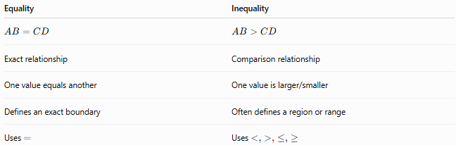
Equality | Inequality
$$AB=CD$$ | $$AB>CD$$
Exact relationship | Comparison relationship
One value equals another | One value is larger/smaller
Defines an exact boundary | Often defines a region or range
Uses $=$ | Uses $<,>,≤,≥$
For example:
$$PA=r$$
defines a circle.
But:
$$PA<r$$
defines the interior of the circle.
Therefore:
$$\boxed{\text{Equality often forms the boundary of an inequality region}}$$

Equality Conditions vs Similarity
# Source: AI Source: Provided by: [Data Path: Persons Table -> ID Column: 1, Name_En Column: Motasem Essam] -> From: [ChatGPT] on [7/25/2026]
A particularly important distinction:
Congruence
$$\boxed{\text{Corresponding lengths are equal}}$$
Similarity
$$\boxed{\text{Corresponding lengths have equal ratios}}$$
For example:
$$AB=DE$$
is an equality of lengths.
But:
$$\frac{AB}{DE}=\frac{BC}{EF}$$
is an equality of ratios.

Classification Summary
# Source: AI Source: Provided by: [Data Path: Persons Table -> ID Column: 1, Name_En Column: Motasem Essam] -> From: [ChatGPT] on [7/25/2026]
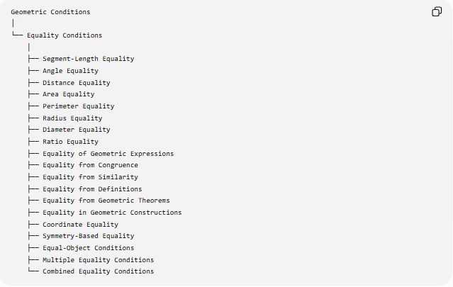
Geometric Conditions
│
└── Equality Conditions
│
├── Segment-Length Equality
├── Angle Equality
├── Distance Equality
├── Area Equality
├── Perimeter Equality
├── Radius Equality
├── Diameter Equality
├── Ratio Equality
├── Equality of Geometric Expressions
├── Equality from Congruence
├── Equality from Similarity
├── Equality from Definitions
├── Equality from Geometric Theorems
├── Equality in Geometric Constructions
├── Coordinate Equality
├── Symmetry-Based Equality
├── Equal-Object Conditions
├── Multiple Equality Conditions
└── Combined Equality Conditions

Core Equality Relationships
# Source: AI Source: Provided by: [Data Path: Persons Table -> ID Column: 1, Name_En Column: Motasem Essam] -> From: [ChatGPT] on [7/25/2026]
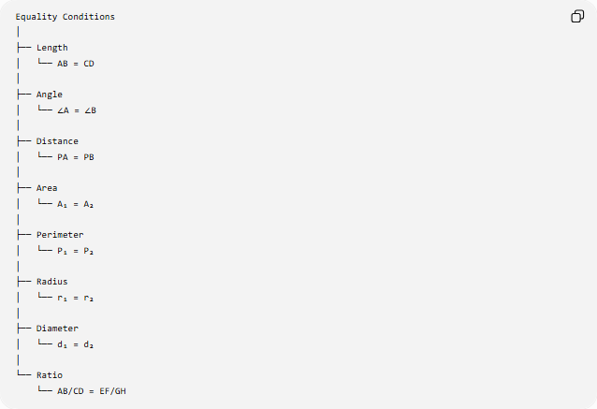
Equality Conditions
│
├── Length
│ └── AB = CD
│
├── Angle
│ └── ∠A = ∠B
│
├── Distance
│ └── PA = PB
│
├── Area
│ └── A₁ = A₂
│
├── Perimeter
│ └── P₁ = P₂
│
├── Radius
│ └── r₁ = r₂
│
├── Diameter
│ └── d₁ = d₂
│
└── Ratio
└── AB/CD = EF/GH

Key Formulas
# Source: AI Source: Provided by: [Data Path: Persons Table -> ID Column: 1, Name_En Column: Motasem Essam] -> From: [ChatGPT] on [7/25/2026]
Segment equality
$$\boxed{AB=CD}$$
Angle equality
$$\boxed{m∠A=m∠B}$$
Distance equality
$$\boxed{PA=PB}$$
Area equality
$$\boxed{A_{1}=A_{2}}$$
Perimeter equality
$$\boxed{P_{1}=P_{2}}$$
Radius equality
$$\boxed{r_{1}=r_{2}}$$
Diameter equality
$$\boxed{d_{1}=d_{2}}$$
Ratio equality
$$\boxed{\frac{AB}{CD}=\frac{EF}{GH}}$$
Midpoint equality
$$\boxed{AM=MB}$$
Angle-bisector equality
$$\boxed{∠ABD=∠DBC}$$
Similar-triangle ratio equality
$$\boxed{\frac{AB}{DE}=\frac{BC}{EF}=\frac{AC}{DF}}$$
Circle radius equality
$$\boxed{OP=r}$$
for every point $P$on a circle centered at $O$.

Key Points
# Source: AI Source: Provided by: [Data Path: Persons Table -> ID Column: 1, Name_En Column: Motasem Essam] -> From: [ChatGPT] on [7/25/2026]
- Equality Conditions require two or more geometric quantities to have exactly the same value.
- Equality can involve:
  - lengths,
  - angles,
  - distances,
  - areas,
  - perimeters,
  - radii,
  - diameters,
  - ratios,
  - expressions.
- The fundamental symbol is:
$$\boxed{=}.$$
- A midpoint creates:
$$AM=MB.$$
- An angle bisector creates:
$$∠ABD=∠DBC.$$
- A perpendicular bisector creates:
$$PA=PB.$$
- Congruence produces equality of corresponding sides and angles.
- Similarity produces equality of corresponding angles and equality of corresponding ratios.
- Symmetry frequently produces equal lengths, angles, or distances.
- Equal area does not imply congruence.
- Equal perimeter does not imply equal area.
- Equality conditions frequently form the boundary between geometric inequality regions.
- Equality conditions can define loci.
- Equality conditions are fundamental in geometric constructions and proofs.
- Equality cases of geometric inequalities often identify special figures such as circles or equilateral triangles.

Conclusion
# Source: AI Source: Provided by: [Data Path: Persons Table -> ID Column: 1, Name_En Column: Motasem Essam] -> From: [ChatGPT] on [7/25/2026]
Equality Conditions are fundamental geometric requirements that state that two or more geometric quantities, measurements, ratios, or properties are exactly equal.
The central structure is:
$$\boxed{\text{Equality Condition}→\text{Equal Geometric Quantities}→\text{Geometric Consequence}}$$
For example:
$$\boxed{AB=AC→\text{Equal Sides}→∠B=∠C} \\ \boxed{PA=PB→\text{Equal Distances}→\text{Perpendicular-Bisector Locus}} \\ \boxed{△ABC≅△DEF→\text{Corresponding Parts Equal}}$$
Therefore, equality conditions provide a central connection between geometric measurement, congruence, similarity, symmetry, loci, constructions, theorems, proofs, and geometric inequalities.

